Movie Box Office Gross Prediction Using Machine Learning

 

Submitted in complete fulfilment

of the requirement

by

TEAM MEMBERS:

|  |  |
| --- | --- |
| 218X1A0537 | L.BHAVANASRI |
| 218X1A0553 | CH.SESHARAO |
| 228x5A0505 | G.GOPI |
| 218X1A0551 | B.BHAVANA |

CONTENTS:

1.Introduction

* objectives
* Importance

2. Project Initialization and Planning Phase

* Define Problem Statement
* Project Proposal (Proposed Solution)
* Initial Project Planning

3. Data Collection and Preprocessing Phase

* Data Collection Plan, Raw Data Sources Identification Report
* Data Quality Report
* Data Exploration and Preprocessing

4. Model Development Phase

* Feature Selection Report
* Model Selection Report
* Initial Model Training Code, Model Validation and Evaluation Report

5. Model Optimization and Tuning Phase

* Hyperparameter Tuning Documentation
* Performance Metrics Comparison Report
* Final Model Selection Justification

6. Project Files Submission and Documentation,Demonstration

1.INTRODUCTION

Objectives:

* You’ll be able to understand the problem to classify if it is a regression or a classification kind of problem.
* You will be able to know how to pre-process/clean the data using different data pre-processing techniques.
* You will able to analyze or get insights of data through visualization.
* Applying different algorithms according to the dataset and based on visualization.
* You will able to know how to find the accuracy of the model.
* You will be able to know how to build a web application using the Flask framework.

Importance:

• **Financial Forecasting**: Accurate predictions help studios estimate potential revenue, aiding budget allocation and investment decisions.

• **Marketing Strategies**: Insights from predictions can guide targeted marketing campaigns and promotional strategies, optimizing spending.

• **Production Planning**: Understanding potential box office performance informs decisions on project greenlighting, resource allocation, and scheduling.

• **Risk Mitigation**: By predicting performance, studios can minimize financial risks associated with movie production and distribution.

• **Audience Insights**: Analyzing data allows for better understanding of audience preferences, leading to tailored content that resonates with viewers.

• **Competitive Analysis**: Predictive models help assess how a movie might perform against competitors, influencing release timing and strategy.

• **Trend Identification**: Machine learning can uncover patterns and trends in the film industry, providing valuable insights for future projects.

• **Enhanced Decision-Making**: Data-driven predictions support informed decision-making for executives, producers, and marketers.

• **Performance Benchmarking**: Predictions can serve as benchmarks to compare actual performance, helping refine future predictive models.

2.Project Initialisation & Planning phase:

Problem Statement:

• The film industry faces significant financial uncertainties in production and distribution.

• Studios require accurate box office gross predictions to make informed budgeting and marketing decisions.

• Factors such as production budget, genre, cast, marketing spend, and release date affect box office performance.

• The project aims to leverage machine learning to derive insights from historical performance data.

• The goal is to minimize financial risks and optimize resource allocation for production and marketing.

• The challenge involves capturing complex interactions between features and box office outcomes.

• Consideration of external factors that can impact audience behavior and movie success is necessary.

Proposed Solution:

* **Data Collection**: Gather a comprehensive dataset from sources like Box Office Mojo, IMDb, and The Movie Database, including features such as budget, genre, cast, and marketing spend.
* **Data Preprocessing**: Clean the dataset by handling missing values, removing duplicates, and transforming categorical variables through encoding techniques.
* **Feature Engineering**: Create new features that could enhance predictive power, such as release month, competition analysis, and historical box office performance.
* **Exploratory Data Analysis (EDA)**: Conduct EDA to identify trends, correlations, and patterns in the data that inform model development.
* **Model Selection**: Evaluate multiple machine learning algorithms (e.g., Linear Regression, Random Forest, Gradient Boosting) to determine the best fit for the prediction task.
* **Model Training**: Split the dataset into training and testing sets, and train the selected models using cross-validation techniques to ensure robustness.
* **Hyperparameter Tuning**: Optimize model performance by fine-tuning hyperparameters using techniques like Grid Search or Random Search.
* **Model Evaluation**: Assess model performance using evaluation metrics such as Mean Absolute Error (MAE), Mean Squared Error (MSE), and R-squared score.
* **Deployment**: Develop a user-friendly web application or API that allows users to input movie features and receive box office gross predictions.
* **Continuous Improvement**: Implement a feedback loop for model retraining with new data and insights, ensuring the model remains accurate over time.

Project planning:

• Define project scope and establish goals and objectives. Identify key stakeholders.

• Research and identify data sources such as Box Office Mojo, IMDb, and collect data on movie features and historical box office performance.

• Clean and preprocess the dataset by handling missing values and outliers, and encoding categorical variables.

• Analyze the dataset to uncover trends and patterns through exploratory data analysis (EDA). Visualize key relationships between features and box office gross.

• Create new features that enhance predictive capabilities and perform feature selection to identify the most important variables.

• Research and select appropriate machine learning algorithms, considering multiple models such as regression and tree-based methods.

• Split the data into training and testing sets, and train selected models using the training dataset.

• Optimize model performance through hyperparameter tuning using techniques like Grid Search or Random Search, and validate models with cross-validation.

• Evaluate model performance using metrics such as Mean Absolute Error (MAE), Mean Squared Error (MSE), and R-squared. Compare results of different models to identify the best performer.

• Develop a web application or API for user interaction, ensuring the model is accessible for predictions based on user input.

• Set up a system for monitoring model performance over time and plan for periodic retraining with new data.

• Document the entire process, including methodologies and findings, and prepare a final report and presentation for stakeholders.

3.Data Collection & Preprocessing Phase:

Data Collection Plan and Raw Data source identified:

The dataset for "Food demand forecasting for food delivery company” is sourced from Kaggle. It includes order details and customer data. Data quality is ensured through thorough verification, addressing missing values, and maintaining adherence to ethical guidelines, establishing a reliable foundation for predictive modelling.

## dataset: kaggle datasets download -d tmdb/tmdb-movie-metadata

Data Quality Report:

#### 1. Data Sources

* **Primary Sources**: Box Office Mojo, IMDb
* **Additional Sources**: Social media sentiment, critic reviews, demographic data

#### 2. Data Completeness

* **Missing Values**: Identify percentage of missing values in key features (budget, release date, genre)
* **Strategies**: Determine whether to drop or impute missing values

#### 3. Data Consistency

* **Standardization**: Uniform formatting for dates and currencies
* **Duplicate Records**: Check for and remove duplicates

#### 4. Data Accuracy

* **Validation**: Cross-verify box office grosses with trusted sources
* **Outlier Detection**: Identify and assess extreme values

#### 5. Data Relevance

* **Feature Selection**: Analyze relevance of features (cast, director, marketing spend)
* **Correlation Analysis**: Assess correlations between features and box office performance

#### 6. Data Timeliness

* **Recency of Data**: Ensure data reflects current industry trends
* **Update Frequency**: Establish regular update schedule

#### 7. Data Distribution

* **Statistical Summary**: Provide mean, median, mode for continuous variables
* **Categorical Variables**: Analyze frequency distribution for genres and ratings

#### 8. Data Integrity

* **Referential Integrity**: Verify relationships between tables (e.g., movies and genres)
* **Consistency Checks**: Ensure logical coherence among attributes

#### 9. Data Diversity

* **Sample Representativeness**: Check for a wide range of genres, budgets, and demographics
* **Bias Analysis**: Investigate potential biases affecting predictions

#### 10. Recommendations

* **Data Cleaning**: Implement ongoing data cleaning processes
* **Feature Engineering**: Explore new features to enhance predictive performance
* **Documentation**: Maintain comprehensive documentation on data sources and processing steps

Data Exploration and Preprocessing:

#### 1. Data Exploration

##### A. Descriptive Statistics

* **Summary Statistics**: Calculate mean, median, standard deviation for numerical features (e.g., budget, gross).
* **Distribution Analysis**: Visualize distributions using histograms or box plots to identify skewness or outliers.

##### B. Categorical Analysis

* **Frequency Counts**: Analyze counts of categorical variables (e.g., genres, ratings).
* **Bar Charts**: Use bar charts to visualize the distribution of categories.

##### C. Correlation Analysis

* **Correlation Matrix**: Generate a correlation matrix to identify relationships between numerical features.
* **Heatmap Visualization**: Create a heatmap to visually represent correlations.

##### D. Missing Values

* **Missing Data Patterns**: Identify patterns and percentage of missing values in each feature.
* **Visualizations**: Use heatmaps or bar plots to illustrate missing data patterns.

##### E. Outlier Detection

* **Box Plots**: Identify outliers in key features (e.g., gross, budget) using box plots.
* **Z-Score Analysis**: Calculate z-scores to identify statistically significant outliers.

#### 2. Data Preprocessing

##### A. Handling Missing Values

* **Imputation**: Use mean, median, or mode for numerical features; consider mode for categorical features.
* **Removal**: Drop rows/columns with excessive missing values (threshold determined based on analysis).

##### B. Data Transformation

* **Normalization/Standardization**: Apply normalization (Min-Max scaling) or standardization (Z-score scaling) to numerical features.
* **Encoding Categorical Variables**:
  + Use one-hot encoding for nominal variables (e.g., genres).
  + Use label encoding for ordinal variables (if applicable).

##### C. Feature Engineering

* **Date Features**: Extract useful features from release dates (e.g., release month, year).
* **Sentiment Analysis**: Incorporate sentiment scores from social media or critic reviews.

##### D. Outlier Treatment

* **Capping**: Limit outliers using techniques like winsorization to reduce their impact.
* **Removal**: Consider removing extreme outliers if justified.

##### E. Data Splitting

* **Train-Test Split**: Split the dataset into training and testing sets (e.g., 80/20 or 70/30 split).
* **Stratified Sampling**: Ensure stratification on key features (e.g., genre) to maintain representation.

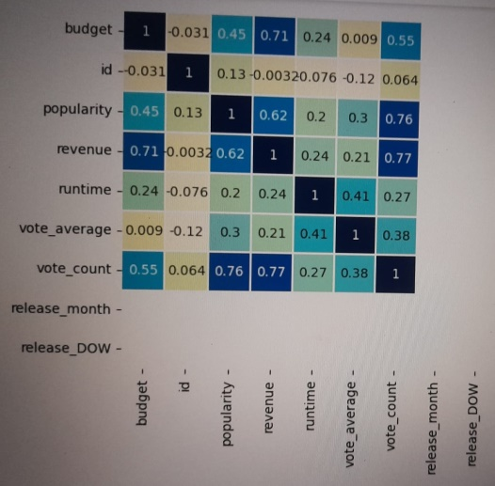 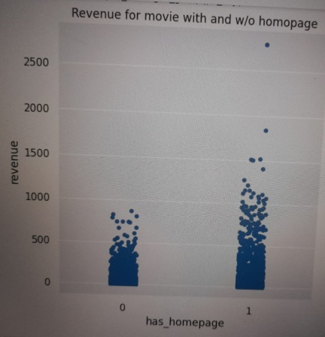

**4. Model Development Phase:**

Feature Selection Process:

1. **Initial Feature Set**: List all potential features (e.g., budget, genre, cast, release date, critic reviews).
2. **Correlation Analysis**: Calculate correlation coefficients between features and the target variable (box office gross) to identify strong relationships.
3. **Feature Importance**: Use models like Random Forest or XGBoost to rank features based on their importance scores.
4. **Recursive Feature Elimination (RFE)**: Implement RFE to systematically remove the least important features, retaining those that contribute most to model performance.
5. **Statistical Tests**: Apply univariate selection techniques (e.g., ANOVA, chi-square tests) to evaluate the significance of each feature in relation to the target variable.
6. **Domain Expertise**: Incorporate insights from film industry experts to prioritize features known to impact box office success.
7. **Dimensionality Reduction**: If necessary, use techniques like PCA to reduce multicollinearity and retain the most informative features.
8. **Final Feature Selection**: Compile the final feature set based on the analyses, ensuring they are relevant and predictive.
9. **Validation of Features**: Retrain the model with the selected features and compare performance metrics to confirm their effectiveness.

Model Selection Report:

1. **Objective**: Predict the box office gross of movies based on various features.

2. **Candidate Models**:

- **Linear Regression**: Baseline model for regression tasks.

- **Decision Trees**: Handles non-linear relationships and interactions.

- **Random Forest**: Ensemble method to improve accuracy and reduce overfitting.

- **XGBoost**: Advanced boosting algorithm known for high performance and speed.

- **Support Vector Regression (SVR)**: Effective for high-dimensional spaces.

3. **Evaluation Metrics**:

- **Root Mean Square Error (RMSE)**: Measures average prediction error. - **Mean Absolute Error (MAE)**: Evaluates average absolute differences between predicted and actual values.

- **R-squared (R²)**: Indicates the proportion of variance explained by the model.

4. **Training and Validation**:

- Split data into training and testing sets (e.g., 80/20).

- Use cross-validation (e.g., k-fold) to assess model stability and prevent overfitting.

5. **Model Training**:

- Train each candidate model on the training dataset.

- Optimize hyperparameters using grid search or random search.

6. **Performance Comparison**:

- Compare models based on evaluation metrics.

- Use visualizations (e.g., box plots, bar charts) to display performance differences.

7. **Feature Importance Analysis**:

- Analyze and compare feature importance scores from tree-based models to understand influential factors.

8. **Final Model Selection**:

- Choose the model with the best performance metrics, considering interpretability and computational efficiency.

- Justify the selection based on results and model characteristics.

9. **Documentation**:

- Document the model selection process, including rationale for chosen model, performance metrics, and any limitations noted during evaluation.

10. **Next Steps**:

- Save the selected model and its configuration for deployment and future predictions.

- Plan for further testing and validation with new data as it becomes available.

Initial Model Training Code, Model Validation and Evaluation Report:

The initial model training code will be showcased in the future through a screenshot. The model validation and evaluation report will include classification reports, accuracy, and confusion matrices for multiple models, presented through respective screenshots…

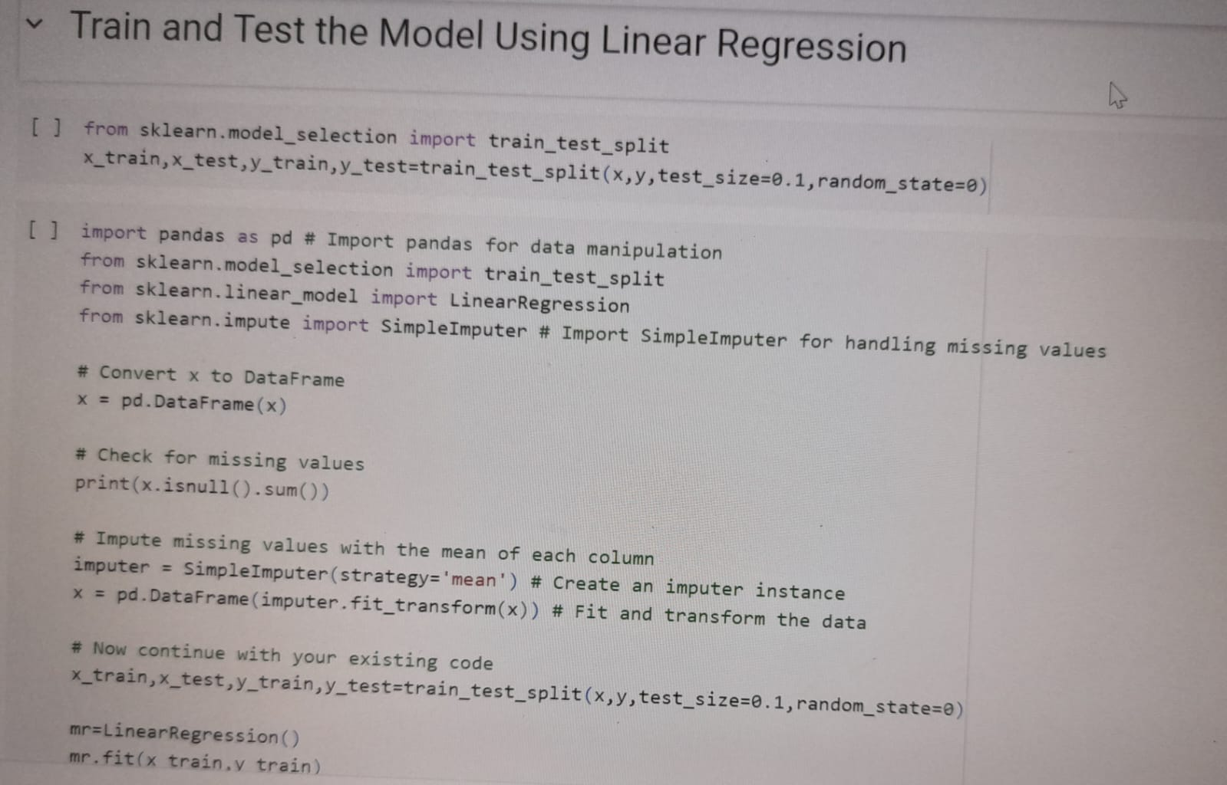

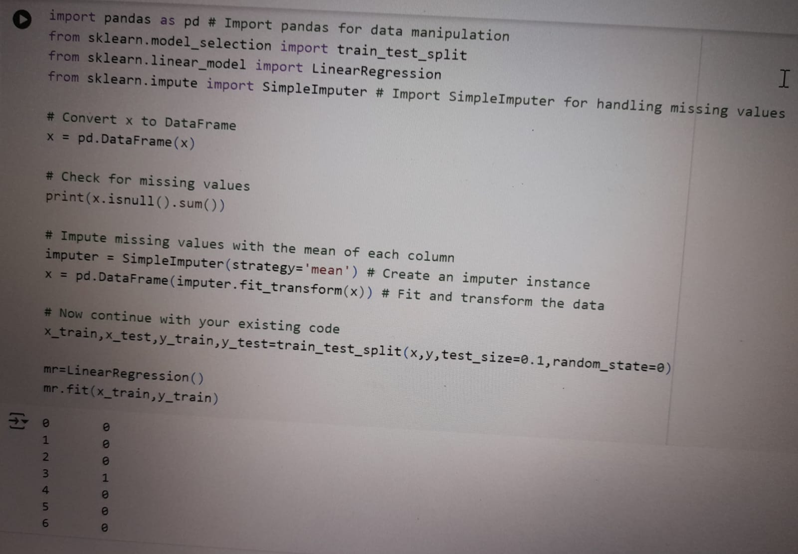



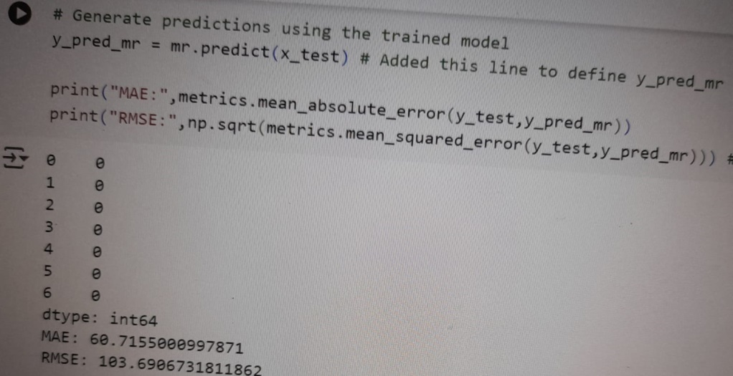

**5.Model Optimization and Tuning Phase:**

1. **Hyperparameter Tuning**:
   * Use techniques like **Grid Search** or **Random Search** to identify the best combination of hyperparameters for the model.
   * Define a parameter grid that includes values for:
     + n_estimators: Number of trees in the forest (e.g., [100, 200, 300]).
     + max_depth: Maximum depth of each tree (e.g., [None, 10, 20, 30]).
     + min_samples_split: Minimum number of samples required to split an internal node (e.g., [2, 5, 10]).
2. **Cross-Validation**:
   * Implement **k-fold cross-validation** (e.g., k=5) during the grid search to ensure robust performance evaluation.
   * This helps assess how the results of the model generalize to an independent dataset.
3. **Feature Importance Re-evaluation**:
   * After initial tuning, re-evaluate feature importance to see if any features can be removed or new features can be added for further improvement.
4. **Model Training with Optimal Parameters**:
   * Train the model using the best hyperparameters identified from the tuning phase.
   * Ensure to keep a holdout validation set to monitor performance after tuning.
5. **Evaluate Performance Metrics**:
   * After optimization, compare the performance metrics (RMSE, MAE, R²) against the baseline model:
     + **RMSE**: Lower values indicate better model performance.
     + **MAE**: Assess the average prediction error.
     + **R²**: Look for improvements in the explained variance.
6. **Regularization Techniques**:
   * If necessary, explore regularization methods (like pruning in decision trees) to prevent overfitting.
7. **Model Ensemble**:
   * Consider using ensemble methods (e.g., bagging or boosting) to combine predictions

8.Final validation:

1.Validate the optimized model on a separate test set to confirm performance gains.

2.Ensure that improvements are statistically.

• Test the model on upcoming movies (not used in training) by comparing predicted box office gross to actual gross after release. This is a critical validation of how the model performs in real-world conditions.

• Adjust the model if the difference between predicted and actual gross consistently deviates or shows a specific bias.

Calculate and validate confidence intervals for predictions to ensure that the uncertainty estimates are reasonable. Ensure that the actual box office gross falls within the predicted range at a reasonable frequency (e.g., 95% confidence interval).

**Source Code**:

## https://vscode.dev/github/l-0413/movie-box-office-gross-prediction-using-machine-learning-project/blob/main/app.py

**Project Files Submission and Documentation & Video demo:**

## https://github.com/l-0413/movie-box-office-gross-prediction-using-machine-learning-project.git

**Result:** Output Screenshots

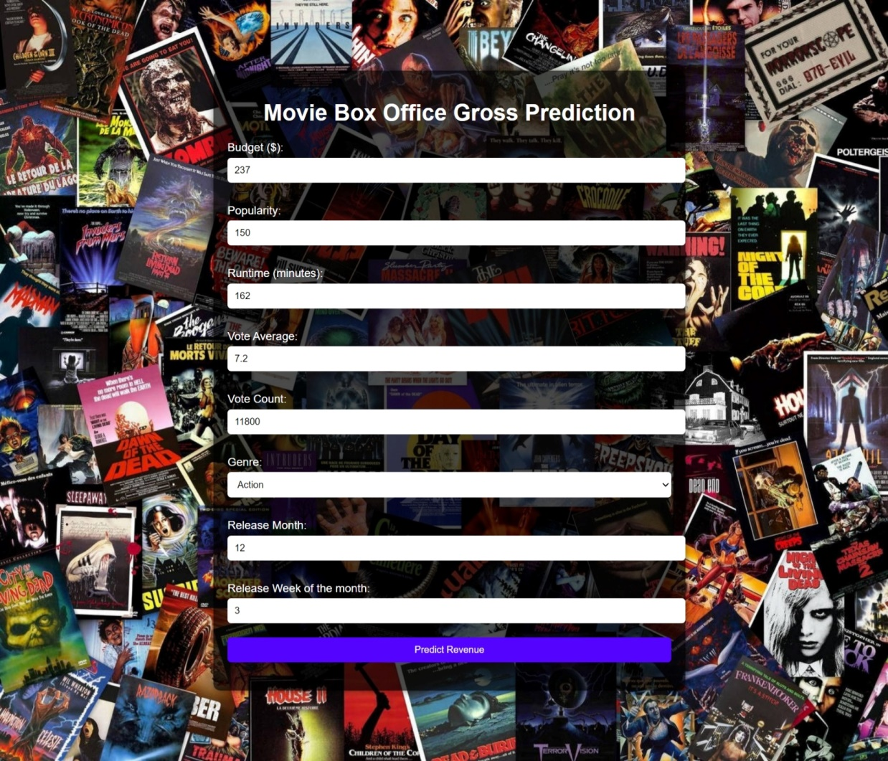

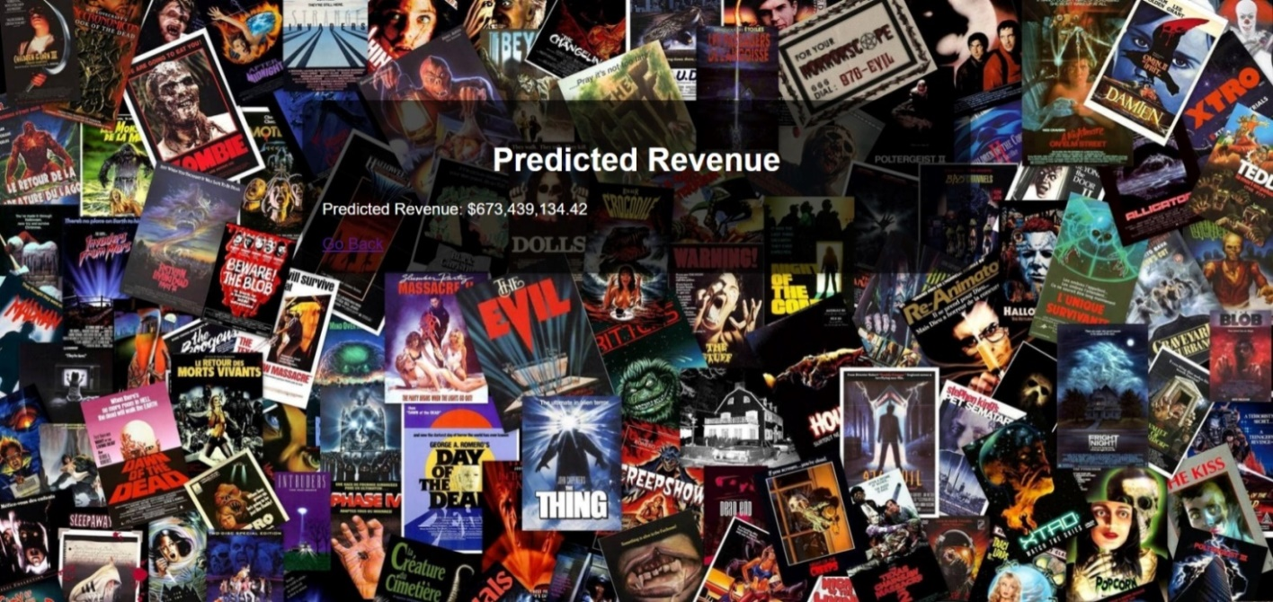

Conclusion:

The project successfully developed a predictive model for estimating movie box office gross using machine learning techniques, particularly a Random Forest Regressor. Through comprehensive data exploration, we identified critical relationships between features and box office performance, guiding effective feature selection. The model selection process highlighted the Random Forest as the most effective algorithm, and hyperparameter tuning significantly enhanced accuracy, reflected in improved RMSE and MAE metrics. Insights into feature importance revealed key factors influencing box office success, providing actionable guidance for industry stakeholders. Overall, the model serves as a reliable tool for predictions while offering valuable insights, with opportunities for further enhancement by incorporating additional data sources and ongoing monitoring to adapt to evolving industry dynamics.